MOP for RSYSLOG Configuration
Phase 0: Pre-checks
0.1 Take Root access
sudo -i
0.2 Note the node's hostname and source IP (the client needs to get this IP allowed in the firewall).
hostname
ip route get 172.19.133.21 | grep -oP 'src \K\S+'
0.3 Check rsyslog is running?
systemctl is-active rsyslog
Expected: active
If not then install by using the given command
- apt install -y rsyslog
- systemctl enable --now rsyslog
- systemctl is-active rsyslog
- rsyslogd -version
0.4 Check kolla log folder?
ls /var/log/kolla
Expected: nova, neutron, ceilometer, etc. folders should be visible
0.5 Check the reachbility of syslog server?
nc -zv 172.19.133.21 514
Expected: succeeded. Stop if you get timeout, Allow the node IP.
0.6 Note ubuntu / rsyslog version
lsb_release -d; rsyslogd -v | head -1
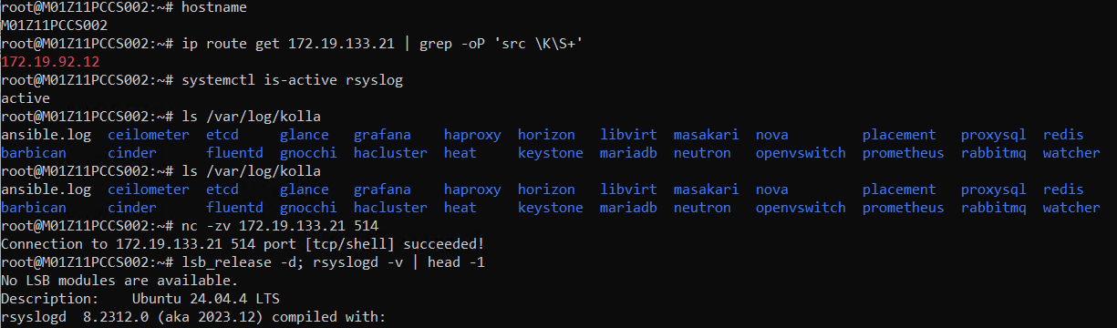

Phase 1: Kolla logs forwarder
Note -> Kolla logs have to be read from a root-owned folder, and AppArmor restricts the normal rsyslogd. That is why we create a separate copy of rsyslogd and a separate service.
1.1 Made rsyslogd copy
cp /usr/sbin/rsyslogd /usr/local/sbin/rsyslogd-kolla
If you get "Text file busy", first run
systemctl stop kolla-rsyslog.
1.2 Made Spool folder
mkdir -p /var/spool/rsyslog-kolla
1.3 Create the config file (add the given config, which defines which logs are shared).
tee /etc/rsyslog-kolla.conf > /dev/null << 'EOF'
global(workDirectory="/var/spool/rsyslog-kolla")
module(load="imfile" PollingInterval="2")

template(name="KollaFmt" type="string"
string="<%PRI%>%TIMESTAMP% %HOSTNAME% %syslogtag% [%$!metadata!filename%] %msg%\n")

ruleset(name="toSyslog") {
action(type="omfwd"
target="172.19.133.21"
port="514"
protocol="tcp"
template="KollaFmt"
action.resumeRetryCount="-1"
queue.type="LinkedList"
queue.size="10000"
queue.maxDiskSpace="1g"
queue.filename="kolla_fwd"
queue.saveOnShutdown="on")
}

input(type="imfile"
File="/var/log/kolla/*/*.log"
Tag="kolla:"
Severity="info"
Facility="local6"
addMetadata="on"
reopenOnTruncate="on"
freshStartTail="on"
ruleset="toSyslog")

input(type="imfile"
File="/var/log/kolla/*.log"
Tag="kolla:"
Severity="info"
Facility="local6"
addMetadata="on"
reopenOnTruncate="on"
freshStartTail="on"
ruleset="toSyslog")
EOF
chmod 644 /etc/rsyslog-kolla.conf
1.4 Validate the Config File
/usr/local/sbin/rsyslogd-kolla -N1 -f /etc/rsyslog-kolla.conf
Expected: check In End of config validation run shows Bye.
If face any error STOP.
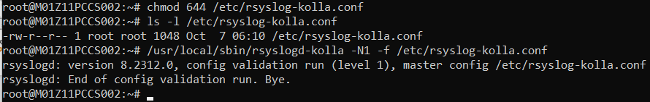

1.5 Made the Service File
tee /etc/systemd/system/kolla-rsyslog.service > /dev/null << 'EOF'
[Unit]
Description=Kolla log forwarder (rsyslog)
After=network-online.target docker.service
Wants=network-online.target

[Service]
ExecStart=/usr/local/sbin/rsyslogd-kolla -n -iNONE -f /etc/rsyslog-kolla.conf
Restart=on-failure

[Install]
WantedBy=multi-user.target
EOF
1.6 Start the service
systemctl daemon-reload
systemctl enable --now kolla-rsyslog
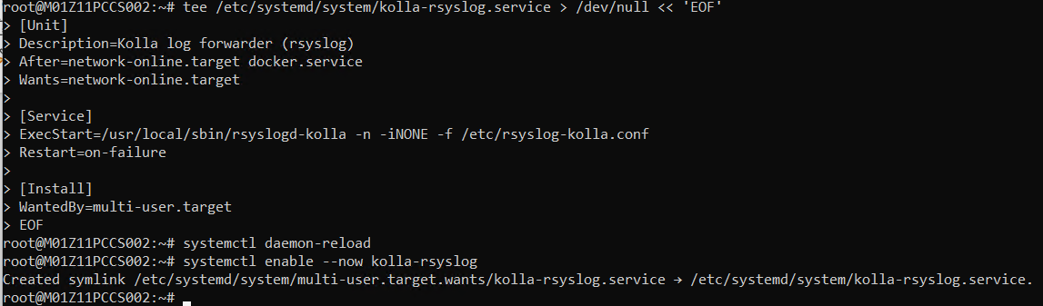
1.7 Status check
systemctl status kolla-rsyslog --no-pager
journalctl -u kolla-rsyslog -n 10 --no-pager
Expected: active (running). Message ansible.log is FILE but DIRECTORY expected - ignored harmless hai.
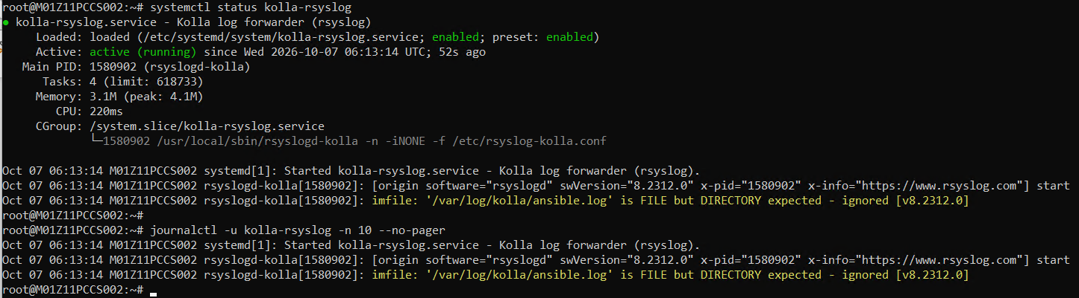
Phase 2: System logs forwarder
2.1 Made the config file
tee /etc/rsyslog.d/50-forward-system.conf > /dev/null << 'EOF'
*.* action(type="omfwd"
target="172.19.133.21"
port="514"
protocol="tcp"
action.resumeRetryCount="-1"
queue.type="LinkedList"
queue.size="10000"
queue.maxDiskSpace="1g"
queue.filename="sys_fwd"
queue.saveOnShutdown="on")
EOF
2.2 Validate
rsyslogd -N1
Expected: In End of config validation run. Bye.
If dace any error then rm /etc/rsyslog.d/50-forward-system.conf to STOP.
2.3 Restart
systemctl restart rsyslog
systemctl is-active rsyslog
Expected: active. (During restart, the AppArmor net_admin DENIED message is normal; ignore it.)
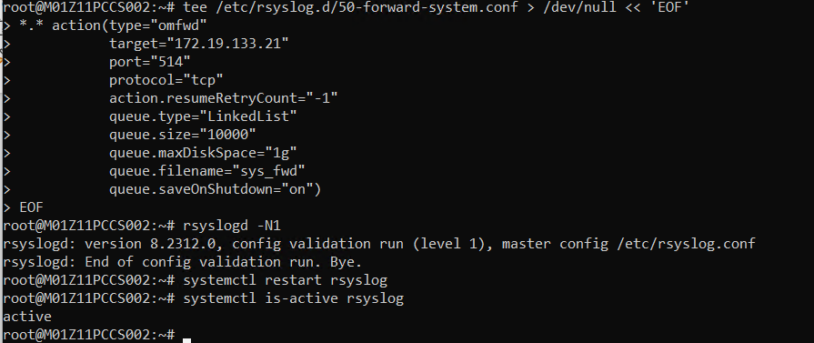

Phase 3: Verification
3.1 Check both services
systemctl is-active rsyslog kolla-rsyslog
Expected: active active
3.2 Connections (2 ESTAB: rsyslogd and rsyslogd-kolla)
ss -tnp dst 172.19.133.21
The Kolla connection is only created when a new line is written to a Kolla log, so it can take 1-2 minutes.
3.3 The server ACKed the data (bytes_acked ≈ bytes_sent).
ss -tni dst 172.19.133.21 | grep -oE "bytes_sent:[0-9]+|bytes_acked:[0-9]+"
3.4 Send the text message
logger "SYSLOG-PROOF-$(hostname)-$(date -u +%Y%m%d_%H%M%S)"
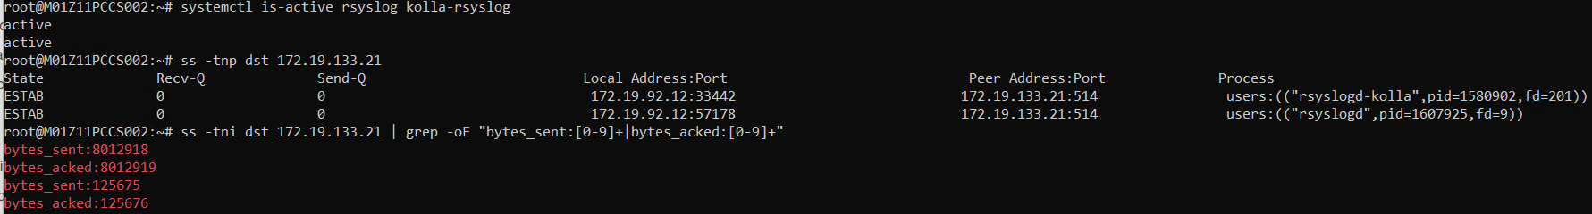
3.5 Check on the wire (run this in a separate terminal first, then run 3.4).
timeout 60 tcpdump -Z root -i any -l -s0 -nn -A 'host 172.19.133.21 and port 514' 2>/dev/null | grep -a "SYSLOG-PROOF"
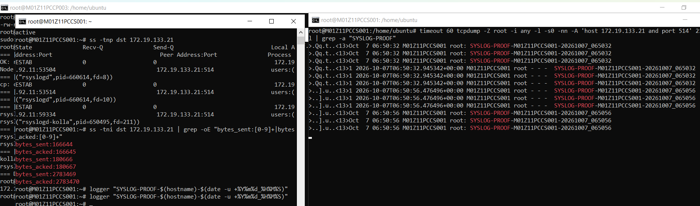
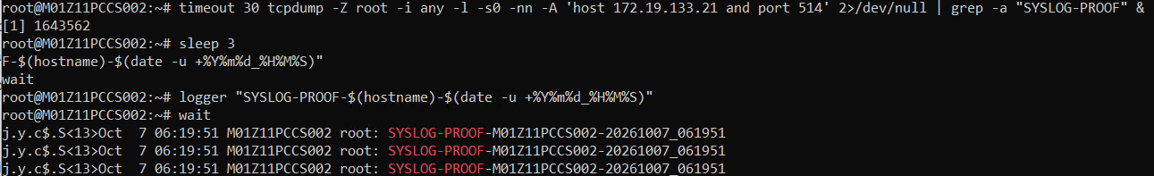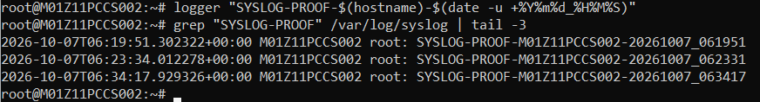
Expected: get the same message on syslog server
3.6 On Kolla line wire
timeout 120 tcpdump -Z root -i any -l -s0 -nn -A 'host 172.19.133.21 and port 514' 2>/dev/null | grep -a --line-buffered "kolla:" | head -3
Expected: kolla: [/var/log/kolla/...] ... If it comes back empty, check: find /var/log/kolla -name "*.log" -mmin -10 (if no file is active, there is nothing to send).

Rollback In case of anything goes Wrong
systemctl disable --now kolla-rsyslog
rm -f /etc/systemd/system/kolla-rsyslog.service /etc/rsyslog-kolla.conf /usr/local/sbin/rsyslogd-kolla
rm -f /etc/rsyslog.d/50-forward-system.conf
systemctl daemon-reload
systemctl restart rsyslog

